Name : Soumya Dixit

Batch : B2

PRN : 23070521151

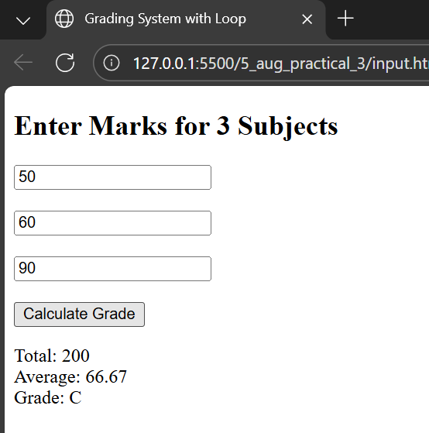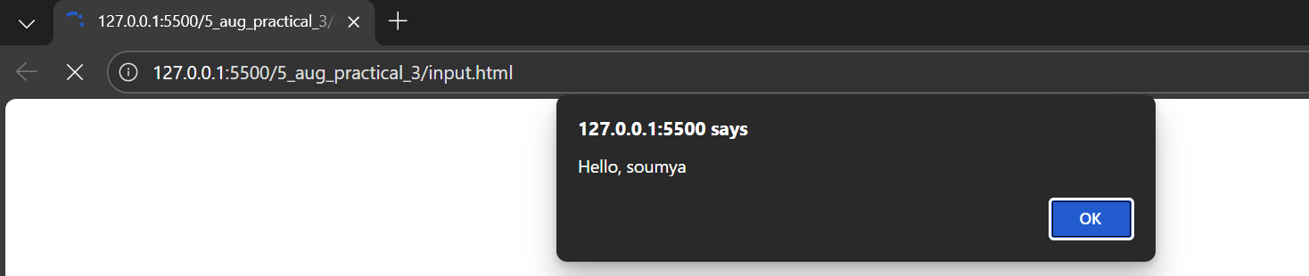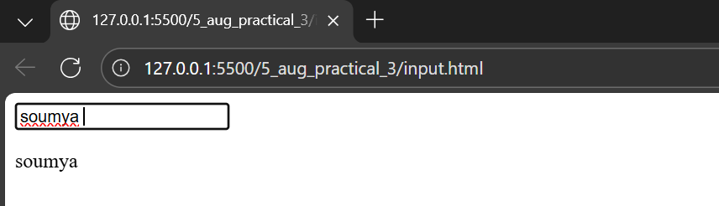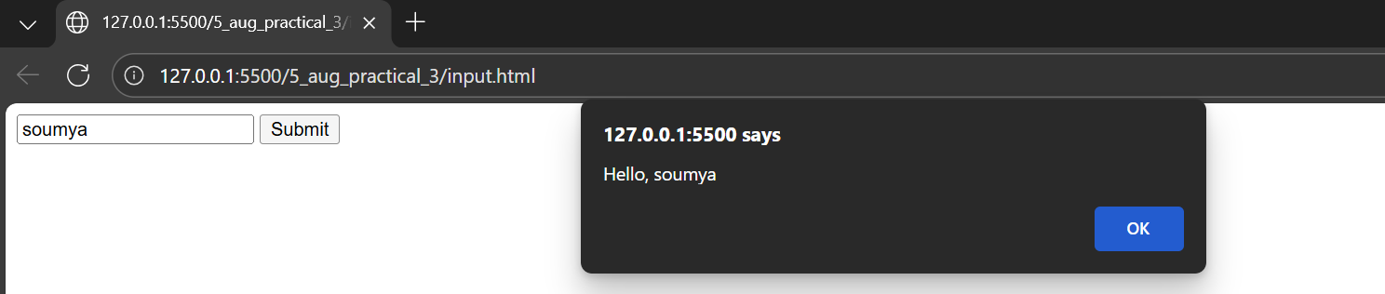

<!DOCTYPE html>

<html>

<head>

<title>Grading System with Loop</title>

</head>

<body>

<h2>Enter Marks for 3 Subjects</h2>

<input type="number" id="mark0" placeholder="Subject 1"><br><br>

<input type="number" id="mark1" placeholder="Subject 2"><br><br>

<input type="number" id="mark2" placeholder="Subject 3"><br><br>

<button onclick="calculate()">Calculate Grade</button>

<p id="result"></p>

<script>

function calculate() {

let total = 0;

let subjectCount = 3;

for (let i = 0; i < subjectCount; i++) {

let mark = parseFloat(document.getElementById("mark" + i).value);

if (isNaN(mark)) {

alert("Please enter valid marks for subject " + (i + 1));

return;

}

total += mark;

}

let average = total / subjectCount;

let grade = "";

if (average >= 90) {

grade = "A+";

} else if (average >= 80) {

grade = "A";

} else if (average >= 70) {

grade = "B";

} else if (average >= 60) {

grade = "C";

} else if (average >= 50) {

grade = "D";

} else {

grade = "F (Fail)";

}

document.getElementById("result").innerText =

"Total: " + total + "\nAverage: " + average.toFixed(2) + "\nGrade: " + grade;

}

</script>

</body>

</html>

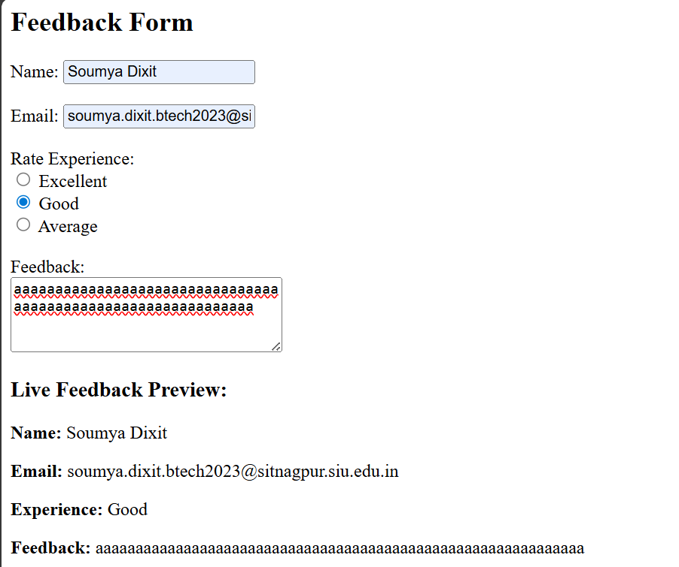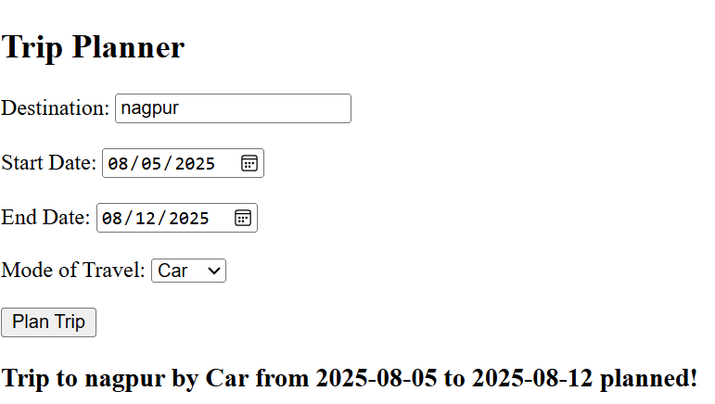

<!DOCTYPE html>

<html lang="en">

<head>

<meta charset="UTF-8">

<title>Feedback & Trip Planner</title>

</head>

<body>

<h2>Feedback Form</h2>

<form id="feedbackForm">

<label>Name:</label>

<input type="text" id="name"><br><br>

<label>Email:</label>

<input type="email" id="email"><br><br>

<label>Rate Experience:</label><br>

<input type="radio" name="rating" value="Excellent"> Excellent<br>

<input type="radio" name="rating" value="Good"> Good<br>

<input type="radio" name="rating" value="Average"> Average<br><br>

<label>Feedback:</label><br>

<textarea id="feedbackText" rows="4" cols="30"></textarea>

</form>

<h3>Live Feedback Preview:</h3>

<p><strong>Name:</strong> <span id="previewName"></span></p>

<p><strong>Email:</strong> <span id="previewEmail"></span></p>

<p><strong>Experience:</strong> <span id="previewRating"></span></p>

<p><strong>Feedback:</strong> <span id="previewText"></span></p>

<hr>

<h2>Trip Planner</h2>

<form id="tripForm">

<label>Destination:</label>

<input type="text" id="destination"><br><br>

<label>Start Date:</label>

<input type="date" id="startDate"><br><br>

<label>End Date:</label>

<input type="date" id="endDate"><br><br>

<label>Mode of Travel:</label>

<select id="travelMode">

<option value="Car">Car</option>

<option value="Train">Train</option>

<option value="Flight">Flight</option>

</select><br><br>

<button type="submit">Plan Trip</button>

</form>

<h3 id="tripMessage"></h3>

<script>

document.getElementById("name").addEventListener("input", function () {

document.getElementById("previewName").innerText = this.value;

});

document.getElementById("email").addEventListener("input", function () {

document.getElementById("previewEmail").innerText = this.value;

});

document.querySelectorAll("input[name='rating']").forEach(function (radio) {

radio.addEventListener("change", function () {

document.getElementById("previewRating").innerText = this.value;

});

});

document.getElementById("feedbackText").addEventListener("keyup", function () {

document.getElementById("previewText").innerText = this.value;

});

document.getElementById("tripForm").addEventListener("submit", function (e) {

e.preventDefault();

const destination = document.getElementById("destination").value;

const start = document.getElementById("startDate").value;

const end = document.getElementById("endDate").value;

const mode = document.getElementById("travelMode").value;

const message = `Trip to ${destination} by ${mode} from ${start} to ${end} planned!`;

document.getElementById("tripMessage").innerText = message;

});

</script>

</body>

</html>